**Assignment 3.3**

We have a dataset of sales of different TV sets across different locations. Records look like: Samsung|Optima|14|Madhya Pradesh|132401|14200 The fields are arranged like: Company Name|Product Name|Size in inches|State|Pin Code|Price There are some invalid records which contain 'NA' in either Company Name or Product Name. 2. Write a Map Reduce program to calculate the total units sold for each Company. 3. Write a Map Reduce program to calculate the total units sold in each state for Onida Company.

2. Write a Map Reduce program to calculate the total units sold for each Company.

**Mapper Class: task2 Mapper**

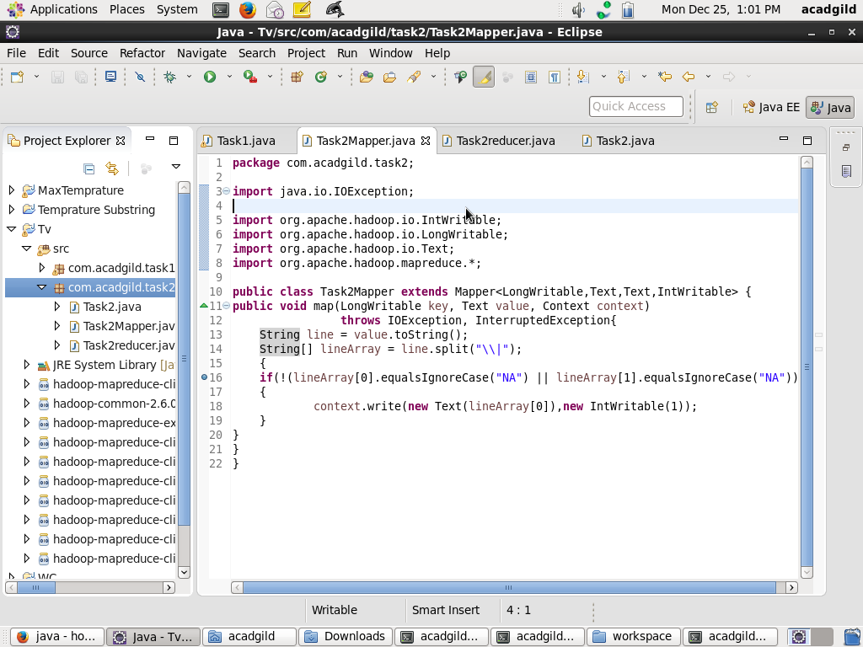

**Reducer class : task2reducer**

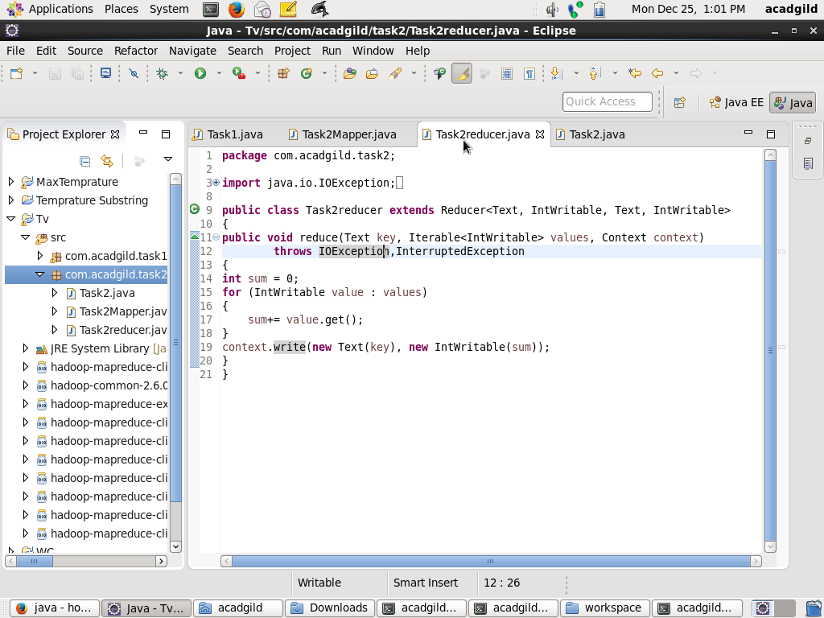

**Driver class : Tak2.java**

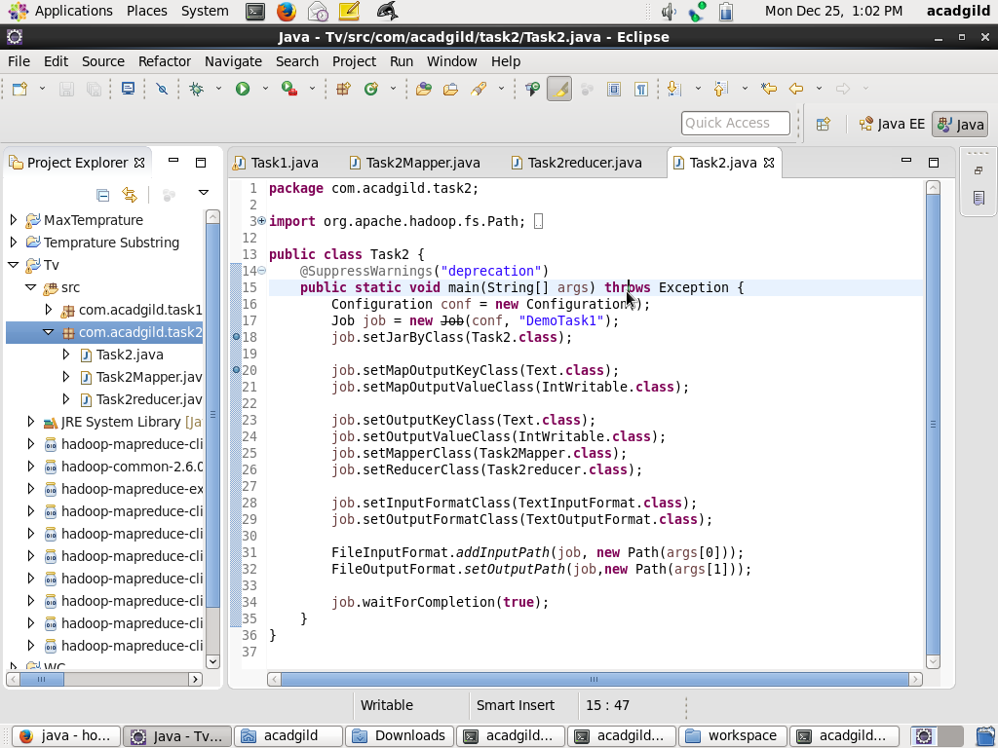

**Execution of the map reduce program**

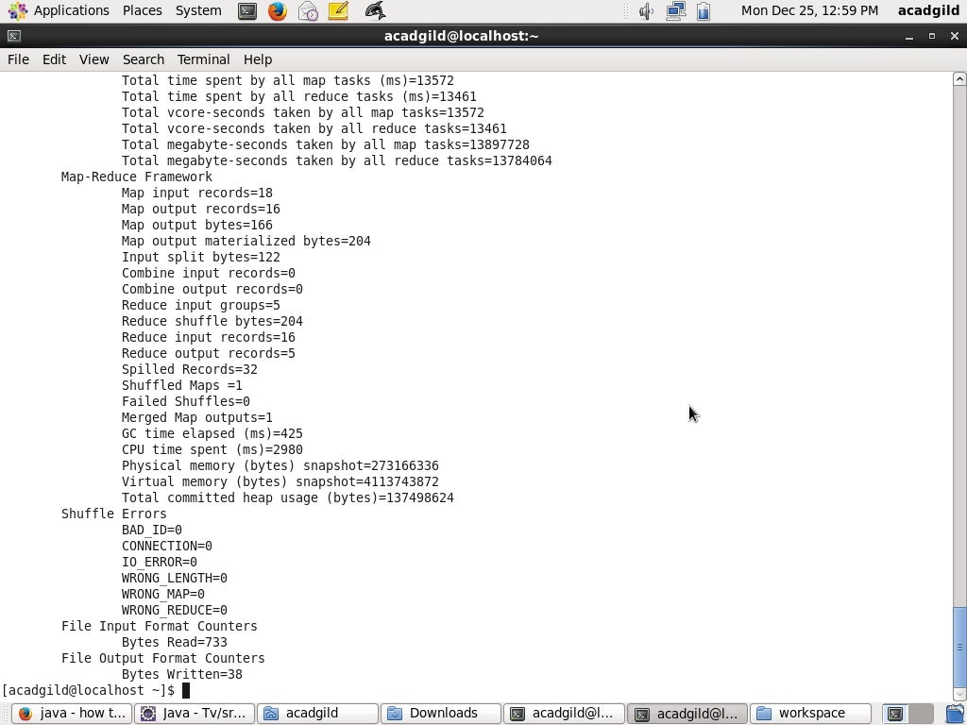

**Results of the mapreduce Program**

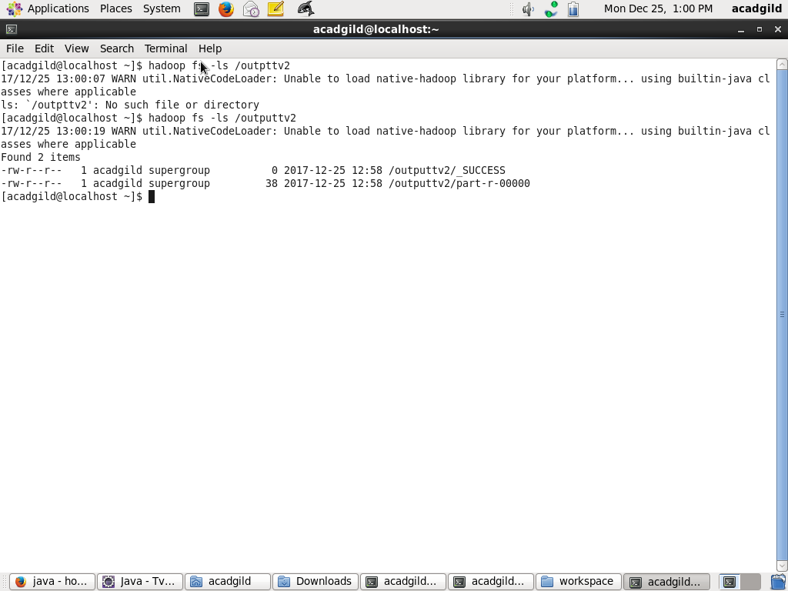

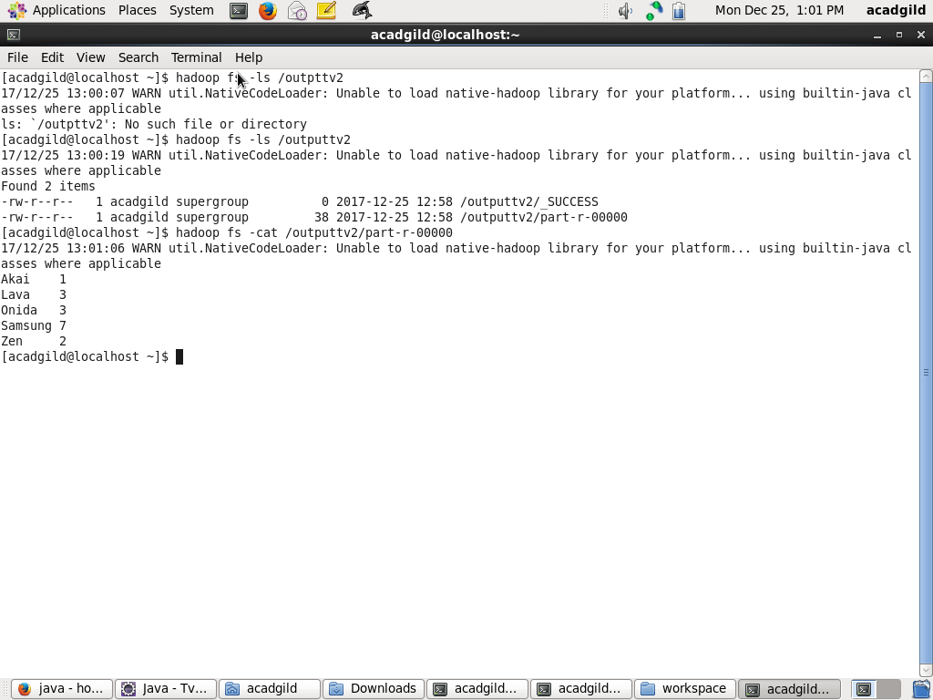

**Input of the file : television.txt**

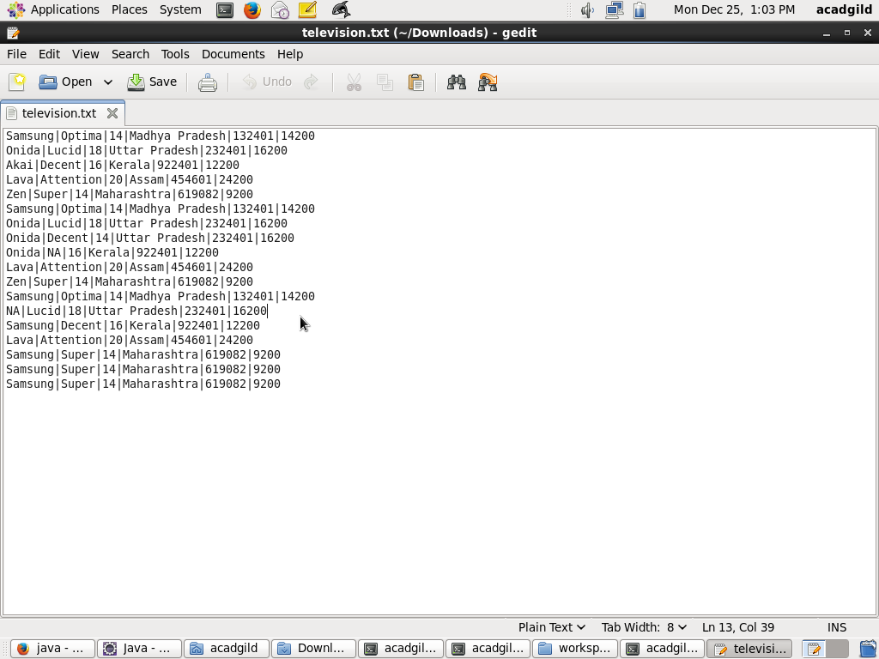

3. Write a Map Reduce program to calculate the total units sold in each state for Onida Company.

Mapper Class :Task3 Mapper

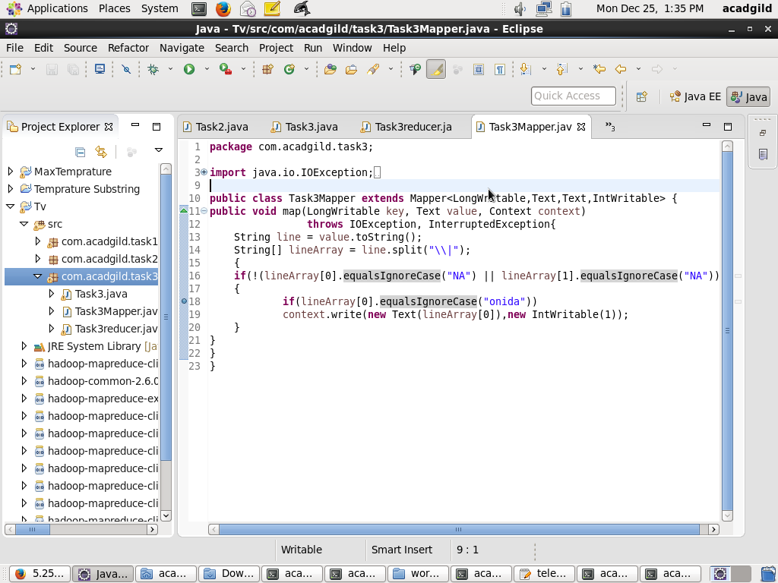

**Reducer Class : task3reducer.java**

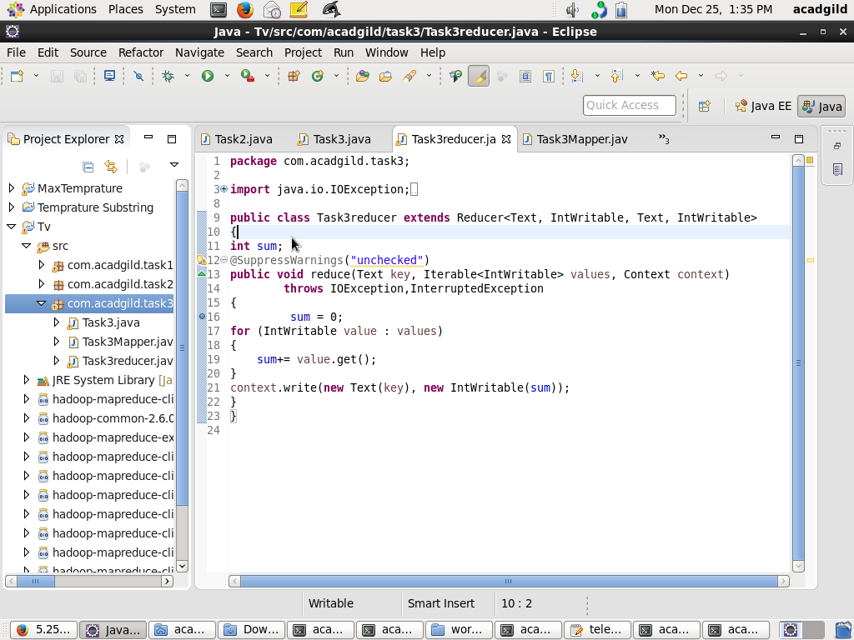

**Execution of the mapreduce**

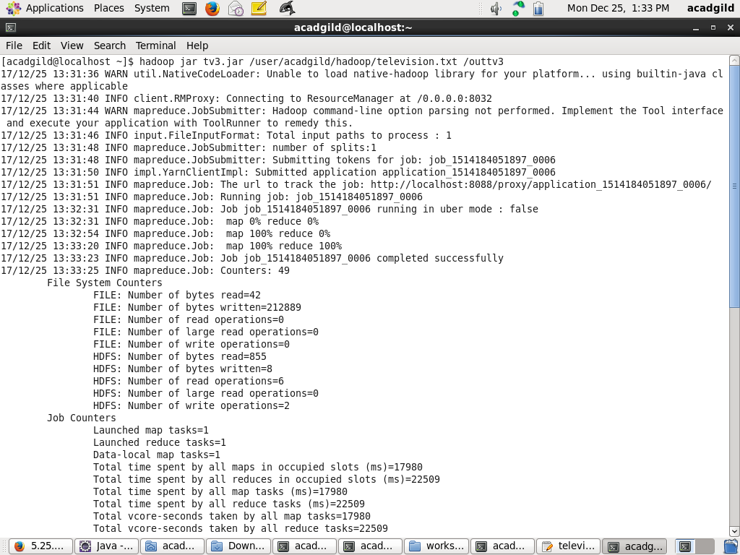

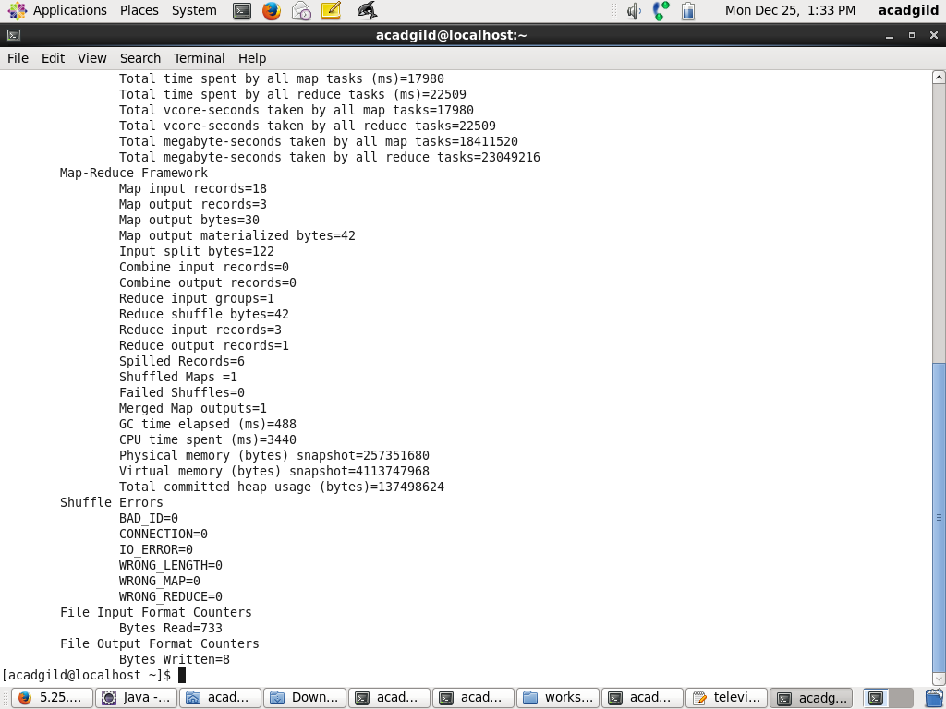

**Results of the mapReduce Executed**

